7 The JavaScript File

Contents

Turn on Sass 1

Set up for the Java Script file 1

Writing the Java Script file 2

Test index page 4

To turn the two bars into an X 4

The Working code for the main.scss file 6

The Working Code for the main.js file 8

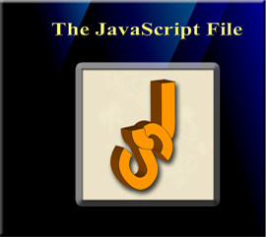

# Turn on Sass

In Visual Studio

Remember to turn on your Watch Sass



# Set up for the Java Script file

You want to open up the dist folder in the side bar on the left of the Visual Studio App

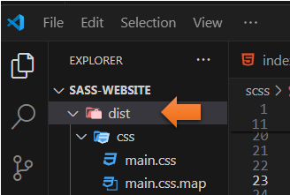

Create another folder inside of the dist folder and name it js. Make sure it is actually in the dist folder

Inside of the js folder create a file and name that main.js.

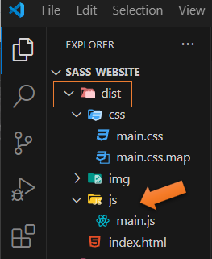

# Writing the Java Script file

We will start by targeting the document object model (DOM). The DOM represents the web page, and it is a way in code, or Java Script in this situation, where we can make changes to the document structure, style and content. The DOM represents the document as nodes and objects, and in this way the Java Script language can use it to interact, or talk to the page.

Set some constants

Start out by not showing the show menu

Add event listener to the menu button

You can think of this classlist as a type of tree. We want to either add or remove branches to it. If the menu is not showing we want to add a class that will open the menu. If the menu is open, we want to remove that class or branch from our tree. So, that the menu will close. These little branches in programing are actually referred to as nodes.

const menuBtn = document.querySelector('.menu-btn');

const hamburger = document.querySelector('.menu-btn__burger');

let showMenu = false;

menuBtn.addEventListener('click', toggleMenu);

function toggleMenu() {

if(!showMenu) {

hamburger.classList.add('open');

showMenu = true;

} else {

hamburger.classList.remove('open');

showMenu = false;

}

}

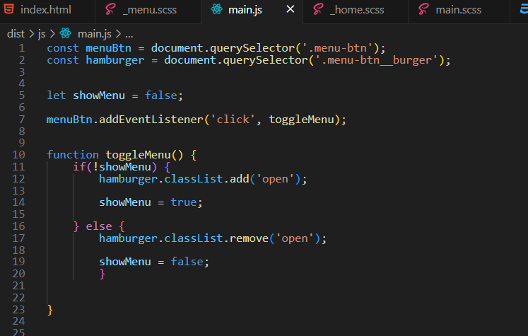

# Test index page

Go to the index.html file to test it

Make sure you are actually clicking on the Hamburger menu to test it.

With the Java Script code in place, when you click the hamburger menu, it should spin around and the middle bar of the menu should disappear, or become transparent

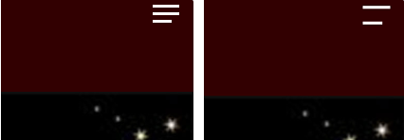

# To turn the two bars into an X

Go into the _menu.scss file, and go in where it says &.open

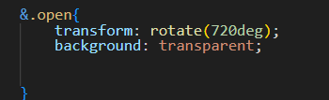

Target the ::before

We want to make this change to it. Here we will target those pseudo elements. Remember where we created that top and bottom bar by using ::before, and ::after.

translate: the first argument represent the horizontal first bar, and the second argument will be the vertical bar.

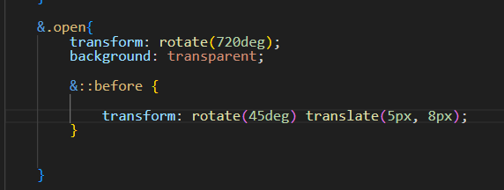

When we click the hamburger menu on the webpage, you will see it looks like this

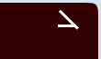

So, it is not quite an X quite yet, but we are working on it.

Target the ::After

Now remember the bottom line is actually set to a shorter width, but in order for it to look like an X, we will need to change it to the same width. You might have to play around with the numbers here to get it to work.

&.open{

transform: rotate(720deg);

background: transparent;

&::before {

transform: rotate(45deg) translate(5px, 8px);

}

&::after{

width: 28px;

transform: rotate(-45deg) translate(3px, -7px);

}

}

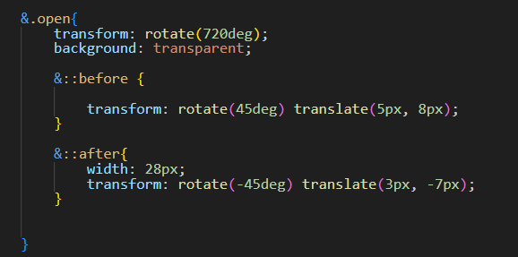

With this set like this, it should now look like this, when you click it.



# The Working code for the main.scss file

.menu-btn {

position:absolute;

z-index: 1;

right: 1rem;

top:1rem;

height: 20px;

width: 28px;

cursor: pointer;

@include transition-ease;

&__burger {

position:absolute;

right: 0;

top: 0.5;

height: 3px;

width: 28px;

background: set-text-color($primary-color);

@include transition-ease;

&::before {

content: '';

position: absolute;

top: -8px;

width: 28px;

height: 3px;

background: set-text-color($primary-color);

@include transition-ease;

}

&::after {

content: '';

position: absolute;

top: 8px;

width: 20px;

height: 3px;

background: set-text-color($primary-color);

@include transition-ease;

}

&.open{

transform: rotate(720deg);

background: transparent;

&::before {

transform: rotate(45deg) translate(5px, 8px);

}

&::after{

width: 28px;

transform: rotate(-45deg) translate(3px, -7px);

}

}

}

}

# The Working Code for the main.js file

const menuBtn = document.querySelector('.menu-btn');

const hamburger = document.querySelector('.menu-btn__burger');

let showMenu = false;

menuBtn.addEventListener('click', toggleMenu);

function toggleMenu() {

if(!showMenu) {

hamburger.classList.add('open');

showMenu = true;

} else {

hamburger.classList.remove('open');

showMenu = false;

}

}